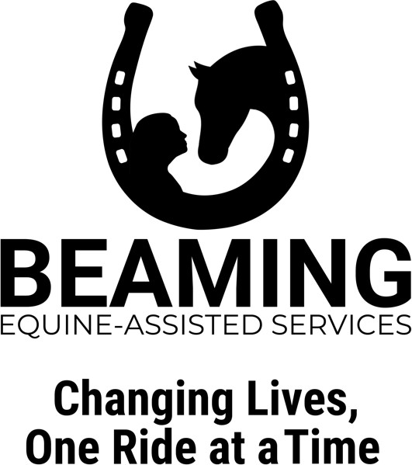
BEAMING Inc.
Reviewer Date of review
(For Office Use Only)
Participant Application

Enter here

For which program(s)

Pony Power Academy
Today’s Date

Participant Name Pronouns
Enter here
Enter here

DOB Age Weight lbs.
Enter here
Enter here
Enter here
Enter here
Address

City State Zip
Enter here
Enter here
Enter here

County of Residence: School
Enter here
Enter here

Diagnosis (if any) Date of Onset
Enter here
Enter here

Medications
Enter here

For our grant writing purposes only: Gender Race
Enter here
Enter here

Qualified for free or reduced lunch? Yes No
Enter here
Enter here
Enter here
Caseworker? Yes No Caseworker email
Enter here
Enter here

Parent/Guardian Name(s)
Enter here

Cell Phone of primary contact
Enter here

Secondary Phone
Enter here

Email address of primary contact
Enter here

Secondary email address
Enter here

Parent/Guardian place(s) of employment
Enter here

How did you hear about BEAMING?
Enter here

06/2023

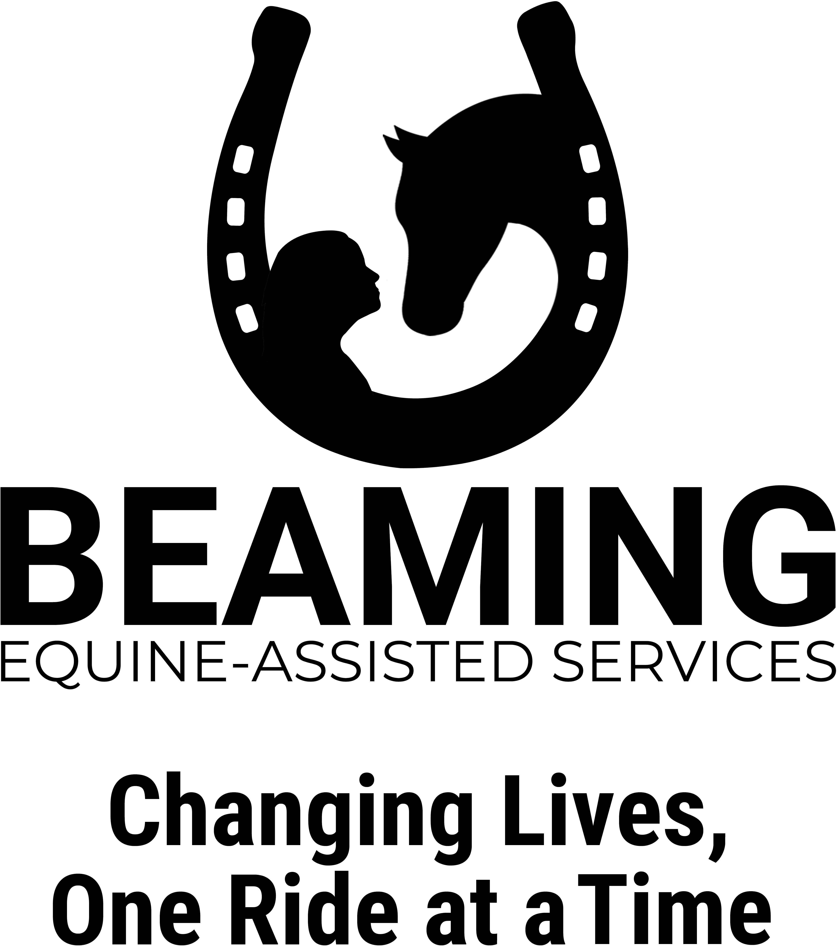
BEAMING Inc.
Release of Liability Agreement Visitor

Enter here
I hereinafter referred as VISITOR, in consideration for the use, today and on all future dates, of the property, facilities and services of KK Quarter Horses LLC, Katie L. Samuelson, BEAMING Inc., instructors, volunteers, Board of Directors, and any and all persons associated with BEAMING Inc. agree as follows: (Capitals indicate terms that will be defined either at the head or at the end of the agreement).

l. VISITOR agrees that when permitted by Wisconsin law, this agreement will be applicable to VISITOR, their heirs, successors, assignees, and representatives.
- MANAGER acknowledges that this Release of Liability does not include intentional behavior on the part of MANAGER or
MANAGER's employees, agents, or representatives.
- VISITOR agrees that not signing a Release of Liability may be a ground for refusal to be admitted within the FACILITIES. VISITOR also agrees that by signing this form, VISITOR is waiving any present, past or future right to negotiate a different Release of Liability with respect to the use of the FACILITIES.
- In case VISITOR desires to modify this Release of Liability, VISITOR should contact the President or MANAGER before attempting to use or enter the FACILITIES.
- This document can only be modified in writing and signed by the President of MANAGER and by VISITOR.
- VISITOR [where applicable] makes this agreement on VISITOR's behalf and on behalf of the following, who is/are VISITOR's child(ren) or legal ward(s).
NAME: DOB: NAME: DOB: NAME: DOB:
Enter here or delete
Enter here or delete
Enter here or delete
Enter here or delete
Enter here or delete
Enter here or delete
VISITOR assumes all responsibility for the safely of VISITOR and any of the above-stated minors. and releases MANAGER and
MANAGER's employees, volunteers, agents, heirs, Representatives, family members, assigns, affiliated persons, visitors and others acting on MANAGER's behalf from any and all claims for injury or death of VISITOR and any minors so designated that may arise from the presence of VISITOR and the minors referenced above on the FACILITIES. VISITOR accepts that this agreement will be applied to VISITOR and any minor so designated. (The term "VISITOR" does include the minors above stated.)
7, VISITOR understands that being allowed on the FACILITIES does not imply a permission to take part in the ACTIVITIES. In case VISITOR desires to take part in the ACTIVITIES, VISITOR shall communicate this desire lo MANAGER's President before taking part in any ACTIVITIES and may not participate in ACTIVITIES until an alternate Release of Liability is signed by VISITOR and VISITOR obtains MANAGER 's or President's permission in writing before taking part in said ACTIVITIES.
3. VISITOR acknowledges that there are inherent risks in being within the proximity of EQUINES, and hereby expressly assumes all risks associated with being close to the EQUINES. These inherent risks include, but are not limited to. the propensity of EQUINES to behave in ways such as, running, bucking, biting, kicking, shying, stumbling, rearing, falling or stepping on that may result in an injury, harm, or death lo persons on or around them.
- VISITOR acknowledges that EQUINES are unpredictable and subject to animal whim and that when frightened, angry or under stress, EQUINES may behave in unforeseen manners. For this reason, VISITOR shall not carry objects that may fall and/or may produce noises that could scare an EQUINE. VISITOR shall abstain from taking pictures and in case that photographs or videos are taken, VISITOR shall use a device (camera or smartphone, among others) that produces no noise and no flash.
- VISITOR acknowledges that MANAGER and MANAGER's employees, agents, heirs, representatives, family members, assigns, affiliated persons, and other, acting on MANAGER's behalf cannot he held responsible for any total or partial ad, such as occurrences or ELEMENTS OF NATURAL, outside of the control of MANAGER, that may affect an EQUINE causing it to react in some unsafe manner.
- VISITOR assumes all responsibility for all risks in connection with VISITOR presence within the facilities and for being in the proximity or EQUINES. VISITOR expressly waives any claims for any injury, loss and/or damage arising from being in the proximity of EQUINES within the FACILITIES. This waiver is with respect to MANAGER and MANAGER's employees, agents, heirs, representatives, family members, assigns, affiliated persons and others acting on MANAGER's behalf.
l2. VISITOR agrees to abide by and follow MANAGER's rules and regulations, which shall be posted and/or available from time to time.

page 1

- VISITOR acknowledges that a full and fair disclosure of VISITOR's physical and mental condition has been made to MANAGER. Therefore, VISITOR waives any responsibility resulting from lack of disclosure or any circumstance (which includes but is not limited to diseases, allergies or pregnancy) that may affect VISITOR while in proximity to EQUINES.
- VISITOR is advised to take all necessary precautions when in the proximity of EQUINES. MANAGER assumes no responsibility in providing VISITOR with safety gear nor to check the condition of any safety gear brought by VISITOR.

VISITOR expressly releases MANAGER and MANAGER's employees, successors and assigns, agents, heirs, representatives, family members, assigns, affiliated persons, and others acting on M ANAGER's behalf from any and all claims for personal injury or property damage resulting from being present within the FACILITIES and in the proximity of an EQUINE.
- VISITOR agrees to hold harmless, indemnify and defend MANAGER and MANAGER's employees, successors and assigns, agents, affiliated persons, and others acting on MANAGER's behalf from any and all claims, demands, causes of action, damages, judgments, orders, costs or expenses, including attorney's fees, whether actually incurred or not, which may in any way arise from or be in any way connected with VISITOR's presence in the FACILITIES.
- VISITOR agrees that should emergency medical treatment be required, VISITOR or VISITOR's accident/medical insurance company shall pay for all such incurred expenses.
- VISITOR acknowledges that no oral representations or other agreements not herein expressed have been made to VISITOR, that this Release of Liability constitutes a complete understanding and that the terms of this Release of Liability are contractual.
- VISITOR accepts that this Release of Liability is governed and should be interpreted under Wisconsin Law and that this agreement is intended to be as broad and inclusive as Wisconsin law permits. Should any part of this document conflict with Wisconsin law, only that part will be nil and void and the rest shall stay in effect. VISITOR also accepts that any disputes that arise from the application or interpretation of this Release of Liability shall be resolved by a Federal or State court of proper jurisdiction located in Wisconsin. VISITOR, therefore, agrees that the legal jurisdiction for this contract will be the State of Wisconsin.
- VISITOR agrees to pay attorney's fees and court costs that may be incurred by VISITOR's breach. VISITOR represents that VISITOR:
  - Is at or over 18 years of age:
  - Is of sound mind, and not suffering from shock or under the influence of alcohol, drugs or intoxicants:
  - Has fully read this Release of Liability and understands it:
  - Understands that signing this Release of Liability represents the waiver of any right to sue due to injuries or death according to what is expressed on this agreement:
  - Has given complete, truthful and accurate information.

DEFIXITIOXS:
ACTIVITIES: Refers, but it is not limited to, training, teaching, riding, inspecting, and evaluating an EQUINE. Riding, training or driving a vehicle pulled by an EQUINE. Assisting in the medical treatment of an EQUINE. Shoeing an EQUINE. Riding as a passenger of an EQUINE. Assisting a person participating in any of these activities.
FAC ILITIES: Refers to the premises upon which Beaming Inc. conducts their activities.
ELEMENT OF NATURE: Includes, but it is not limited to, thunder, lightning, rain, wind, water, wild and domestic animals (which includes other EQUINES, insects and reptiles, dogs, cats, among others), irregular footing on out-of-door groomed or wild land. Land is subject to constant change in conditions according to weather, temperature, and animal and man-made changes in landscape.
EQUINE: includes, but it is not limited to, donkeys, hinnys, horses, mules and ponies.

Enter here

VISITOR Center Director or President
Enter here or delete

Signature of parent or guardian (if under age 18)
I agree and understand that by signing this form electronically, this electronic signature is the legal equivalent of my manual/handwritten signature and I consent to be legally bound by this agreement.

Date
Enter here
DATE

01/10/2023 page 2

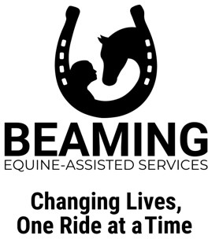
BEAMING INC. POLICIES

MEDIA RECORDING POLICY
Everyone at BEAMING Inc. is prohibited from making recordings including, but not limited to video, audio, photos unless given permission by the Center Director or on-site staff at the time of recording. If permission is granted, personal recordings are not to be used for social media or commercial purposes. This policy has been implemented to protect the privacy of all participants and their families.

CONFIDENTIALITY POLICY
I agree to respect and observe privacy and confidentiality of the participants, volunteers, employees, board members, officers, and donors of BEAMING Inc. and will not discuss or disclose any information about any individual or their family.

REFUSAL OF SERVICES POLICY
If the participant is currently experiencing any of the following symptoms, BEAMING Inc. may refuse to provide service(s): (i) an active threat to self or others;
(ii) in need of inpatient services or intensive outpatient care; (iii) struggling with active self-harm which requires medical attention; (iv) struggling with violent outbursts; or (v) experiencing psychosis.

SESSION CANCELLATION POLICY
Cancellations may be initiated by BEAMING Inc. due to bad weather or other circumstances. The safety of our participants, volunteers, employees, and horses is our top priority. Cancellations will be posted on our Facebook page at: https://www.facebook.com/beaminginc.

ABSENCE POLICY
Please give advance notice if your participant will miss a session for any reason by sending an email to wendy.beaming@gmail.com. Please include the date and time of the planned absence. Please give as much advance notice as possible so we can arrange for a substitute participant.
If your participant is ill on the day of the session, please text (920) 851-6160.
Participants or their parent(s)/guardian(s) will be invoiced personally for any absence for which there is no prior notification.
By signing below, I confirm I have read and understand BEAMING Inc.’s Media Recording Policy, Confidentiality Policy, Refusal of Service Policy, Session Cancellation Policy and Absence Policy.

Enter here
Enter here or delete
Enter here

Participant Signature of Responsible Party Date
I agree and understand that by signing this form electronically, this electronic signature is the legal equivalent of my manual/handwritten signature and I consent to be legally bound by this agreement.
07/2023

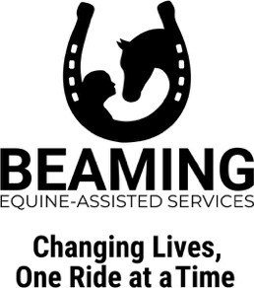
INFECTIOUS DISEASE POLICY

I, , am aware of the risks of contracting or spreading infectious disease (i.e., COVID-19, flu, colds) while working or volunteering at BEAMING, Inc. (“BEAMING”); attending an event; visiting and/or receiving services from BEAMING, Inc. at KK Quarter Horses, LLC (“KK”).
Enter here

I am aware that face-to-face experiences increase my risk of contracting and passing on an infectious disease and agree to hold harmless BEAMING and KK and its residents, members, officers, managers, agents, volunteers, employees and all other individuals affiliated with BEAMING and KK.

I agree to stay home and/or cancel my services should I have personally exhibited or have been in contact with someone who has presented with signs of illness within the previous twenty-four (24) hours to two (2) weeks, including; cough, sneezing, fever, chest congestion or additional signs of potential spread of any infectious disease.

By signing below, I confirm I have read and understand BEAMING Inc.'s Infectious Disease Policy.

Enter here
Enter here or delete
Enter here

Participant Signature of Responsible Party Date
I agree and understand that by signing this form electronically, this electronic signature is the legal equivalent of my manual/handwritten signature and I consent to be legally bound by this agreement.

PHOTO, AUDIO, AND VIDEO RELEASE

For valuable consideration given and which is hereby acknowledged, the undersigned hereby grants to BEAMING Inc. permission to take, or have taken, still and moving photographs and films including television pictures and written and video testimonials of the named Participant, and consents and authorizes BEAMING Inc., its advertising agencies, collaborators, news media, and any other persons interested in BEAMING Inc. and its programs, to use and reproduce the photographs, films, videos, pictures and testimonials, and to circulate and publicize the same by any means deemed appropriate by BEAMING Inc. including, without limitation the generality of the foregoing: newspapers, web sites, social media, videos, television media, brochures, pamphlets, instructional materials, books, and clinical materials.
With respect to the foregoing matters, no inducements or promises have been made to secure this signature to this release other than the intention of BEAMING Inc. to use, or cause to be used, such photographs, films, videos, pictures and testimonials for the primary purpose of promoting and aiding BEAMING Inc. and the field of equine-assisted services.

I give consent:
Enter here
Enter here
Enter here or delete

Participant Signature of Responsible Party Date

I do not give consent:
Enter here or delete
Enter here
Enter here or delete
Participant Signature of Responsible Party Date
06/2023
I agree and understand that by signing this form electronically, this electronic signature is the legal equivalent of my manual/handwritten signature and I consent to be legally bound by this agreement.

