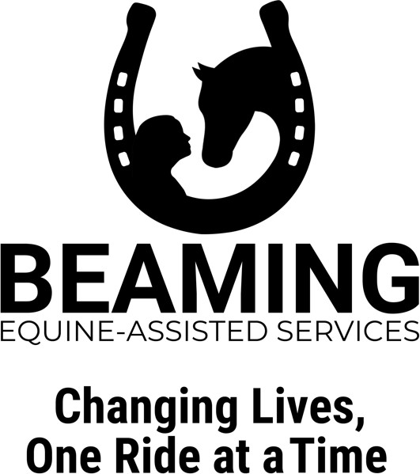

# INTAKE FORM

Date Participant’s Name

Enter here

Enter here

Birth date Weight (Please call if weight is over 200 lb.) Height

Enter here

Enter here

Enter here

Enter here

Care Partner's Name Email Phone Address   
County City State ZIP

Enter here

WI

Enter here

Enter here

Enter here

Enter here

Enter here

Enter here

Current Living Situation (At home/Assisted Living, etc.)   
How long?   
Optional (for our grant writing purposes only) Gender Race

Enter here

Enter here

Enter here

### Participant Profile:

Strengths and Abilities

Enter here

Presenting Problems/Concerns

Enter here

Important life experiences, values or interests (i.e., career, family, favorite style of music)

Enter here

Participant’s daily activities and routines

Enter here

### Program Specific

Past interactions with horses, animals or farms

Enter here

Goals (i.e., personal, family, horsemanship)

Enter here

Page 1

Would you, as a care partner, like to….

Yes/No

Become a volunteer (i.e., a side walker) with your participant during RIM visits

Yes/No

Become a volunteer engaging in other activities (i.e., weeding, sweeping)

Yes/No

Use the program time to socialize with other members or friends at the center

Yes/No

Use the program time to learn about helpful resources related to your caregiving responsibilities and health and well-being

### Participant Health Information

Primary Diagnosis

Enter here

Secondary Diagnosis

Enter here

Physical Disabilities/Limitations

Enter here

DNR (do-not-resuscitate) Status

Enter here

Allergies

Enter here

### Emergency Contact

Name Relationship Phone(s)

Enter here

Enter here

Enter here

### Referral Source

How did you find our services? (check all that apply)

Enter here

Professional reference - name: Friends or Family - name:

Enter here

Enter here

Website Social Media Drive by Other (describe):

Enter here

07/2021 Page 2

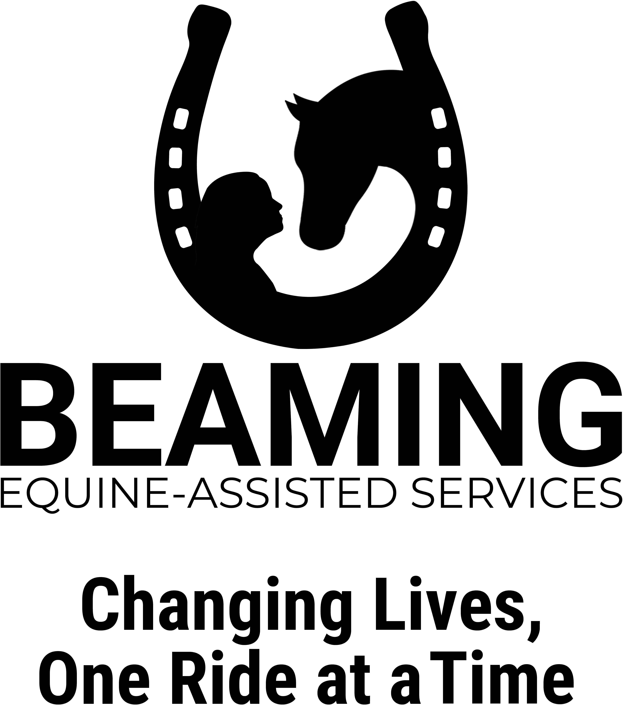

**BEAMING Inc.**

**RELEASE OF LIABILITY AGREEMENT OWNER/RIDER/TRAINER**

I, , hereinafter referred as RIDER, for considerations received, and in return for the use, today and on all future dates of the property, facilities and services of KK Quarter Horses LLC., Katie L. Samuelson, BEAMING Inc., instructors, volunteers, Board of Directors, and any and all persons associated with BEAMING Inc., hereinafter referred to as MANAGER, I (RIDER) hereby agree as follows:

Enter here

**(Capitals indicate terms that will be defined either at the head or at the end of the agreement.)**

* 1. RIDER agrees that when permitted by Wisconsin law, this agreement will be applicable to RIDER's heirs, assigns and representatives.
  2. MANAGER acknowledges that this Release of Liability does not include intentional nor negligent behavior from part of MANAGER or MANAGER's employees, agents or representatives.
  3. RIDER acknowledges that this form is a Release of Liability, which is separated from any other contract that RIDER may have or may sign with MANAGER.
  4. RIDER agrees that not signing a Release of Liability may be a ground for refusal to be admitted within the FACILITIES or to participate in the ACTMTIES. RIDER also agrees that by signing this form, RIDER is waiving any present, past or future right to negotiate a different Release of Liability form with respect to these ACTIVITIES.
  5. In **case that RIDER desires to modify this Release of Liability form,** RIDER should communicate it to MANAGER's Center Director. RIDER shall do this before attempting to enter the FACILITIES or taking part in the ACTIVITIES.
  6. This document can only be modified in writing and signed by MANAGER's Center Director.
  7. RIDER [where applicable] makes this agreement on behalf of the following, who is/are RIDER's child(ren) or legal ward(s): (mm/dd/yyyy)

Enter here or delete

Enter here or delete

NAME: DATE OF BIRTH:

Enter here or delete

NAME: DATE OF BIRTH:

Enter here or delete

Enter here or delete

NAME: DATE OF BIRTH:

Enter here or delete

RIDER assumes all responsibility for the safety of this/these minor(s) and releases MANAGER and MANAGER's employees, successors and assigns, agents, heirs, representatives, family members, assigns, affiliated persons, and others acting on MANAGER's behalf from any and all claims for injury or death of the minor(s) that may arise from ACTIVITIES performed within the FACILITIES. RIDER accepts that this agreement will be applied to this/these minors ("RIDER" hereinafter will also refer to this/these minor(s)).

* 1. RIDER agrees to have read the following notice, which is included according to s. 895.481(5) of the Wisconsin Statutes:

**Wis. Stat. 895.481(4)...**

**"Notice: A person who is engaged for compensation in the rental of equines or equine equipment or tack or in the instruction of a person in the riding or driving of an equine or in being a passenger upon an equine is not liable for the injury or death of a person involved in equine activities resulting from the inherent risks of equine activities, as**

**defined in section 895.481(1)(e) of the Wisconsin Statutes."**

* 1. RIDER acknowledges there are inherent risks with these ACTIVITIES, and hereby expressly assumes all risks associated with participating in such ACTIVITIES. The inherent risks include, but are not limited to the propensity of EQUINES to behave in ways such as, running, bucking, biting, kicking, shying, stumbling, rearing, falling or stepping on, that may result in an injury, harm or death to persons on or around them.

Page 1 of 3

* 1. RIDER acknowledges that EQUINES are unpredictable and subject to animal whim and that when frightened, angry or under stress, EQUINES may behave in unforeseen manners. For this reason, RIDER should not carry objects that may fall and/or may produce noises that could scare an EQUINE. RIDER assumes full responsibility for all risks in connection with ACTIVITIES performed within the FACILITIES, and expressly waives any claims for any injury, loss, and/or damage arising from the participation of RIDER in these ACTIVITIES.
  2. RIDER acknowledges that MANAGER and MANAGER's employees, agents, successors and assigns, heirs, representatives, family members, assigns, affiliated persons, and others acting on MANAGER's behalf cannot be held responsible for any total or partial act, occurrences or ELEMENTS OF NATIJRE, outside of the control of MANAGER that may affect an EQUINE causing it to react in some unsafe manner.
  3. RIDER agrees to abide by and follow MANAGER's rules and regulations, which shall be posted and/or available from time to time. RIDER also acknowledges that the behavior of any animal is contingent to some extent upon the ability of the handler and then once mounting and taking up the reins of an EQUINE, RIDER is in primary control. RIDER agrees to be fully responsible for RIDER's own safety and that of any other person that may accompany or be close to RIDER while in control of an EQUINE within the FACILITIES.
  4. RIDER acknowledges that a full and fair disclosure of RIDER's abilities has been made to MANAGER. RIDER waives any responsibility resulting from lack of disclosure of any circumstance known or that should have been known that may impede or limit the performance of RIDER.
  5. **If RIDER is pregnant,** RIDER assumes full responsibility for the safety of any unborn child and releases MANAGER and MANAGER's employees, agents, successors and assigns, heirs, representatives, family members, assigns, affiliated persons, and others acting on MANAGER' s behalf against any injury or death that is sustained or suffered by the unborn child while performing any ACTIVITIES within the FACILITIES.
  6. RIDER is advised to wear a properly fitted and secured HELMET every time riding or near EQUINES. **RIDER**

**ACKNOWLEDGES THAT THIS IS AN INDISPENSABLE REQUIREMENT FOR ANY PERSON UNDER THE AGE OF 18 TO PARTICIPATE IN THE ACTIVITIES WITHIN THE FACILITIES.**

MANAGER assumes no responsibility in providing RIDER with an appropriate HELMET, to check the condition of any HELMET or helmet strap used by RIDER or any other person, nor to monitor the compliance with these requirements at any time neither now nor in the future. RIDER assumes any and all responsibility for the decision to wear or not to wear a HELMET.

* 1. RIDER acknowledges that it is a requirement to participate in the ACTIVITIES within the FACILITIES to wear APPROPRIATE RIDING SHOES.
  2. RIDER understands that it is RIDER's duty to inform MANAGER or any MANAGER's employee of any concern or issue with respect to the EQUINE or the EQUINE's equipment as soon as this concern or issue is known by RIDER. RIDER acknowledges that the lack of disclosure of these issues or concerns releases MANAGER and MANAGER's employees, agents, successors and assigns, heirs, representatives, family members, assigns, affiliated persons, and others acting on MANAGER's behalf from any and claims for personal injury or property damage resulting from taking part in ACTIVITIES within the FACILITIES.
  3. RIDER expressly releases MANAGER and MANAGER's employees, successors and assigns, agents, heirs, representatives, family members, assigns, affiliated persons, and others acting on MANAGER's behalf from any and all claims for personal injury or property damage resulting from participation of RIDER in the ACTIVITIES within the FACILITIES.
  4. RIDER agrees to hold harmless, indemnify and defend MANAGER and MANAGER's employees, successors and assigns, agents, affiliated persons, and others acting on MANAGER's behalf form any and all claims, demands, causes of action, damages, judgments, orders, costs or expenses, including attorney's fees, whether actually incurred or not, which may in any way arise from or be in any way connected with RIDER's participation in the ACTIVITIES, use of or presence within the FACILITIES.
  5. **In the event of RIDER using RIDER's own EQUINE** or any other EQUINE not owned by MANAGER, RIDER warrants that said EQUINE(s) shall be free from infection, contagious or transmittable disease and shall provide proof of negative Coggins. MANAGER reserves the right to refuse access or the use of any EQUINE upon the FACILITIES that does not appear to MANAGER to be in good health, or is deemed dangerous or undesirable. RIDER assumes responsibility for any disease that may be occasioned to the EQUINES of MANAGER due to the introduction of a strange EQUINE within the FACILITIES. RIDER assumes all responsibility due to damage or property or any injury caused by a strange EQUINE introduced within the FACILITIES by RIDER.

Page 2 of 3

* 1. RIDER assumes full responsibility and waives any claim in the case that RIDER decides to use RIDER's own trainer(s), instructor(s), or clinician(s). RIDER also accepts that any independent instructor(s), trainer(s), or clinician(s) not affiliated with MANAGER operate as independent businesses and do not have an employment, partnership, joint venture, principal-agent or similar arrangement with MANAGER.
  2. RIDER agrees that should emergency medical treatment be required, RIDER or RIDER's accident/medical insurance company shall pay for all such incurred expenses.
  3. RIDER acknowledges that no oral representations or other agreements not herein expressed have been made to RIDER and that this Release of Liability constitutes a complete understanding and that the terms of this Release of Liability are contractual.
  4. RIDER accepts that this Release of Liability is governed and should be interpreted under Wisconsin law and that this agreement is intended to be as broad and inclusive as Wisconsin law permits. Should any part of this document conflict with Wisconsin law, only that part will be null and void and that the rest shall stay in effect. RIDER also accepts that any disputes that arise from the application or interpretation of this Release of Liability should be resolved by a Federal or State court of proper jurisdiction located in Wisconsin. RIDER, therefore, agrees that the legal jurisdiction for this contract will be the State of Wisconsin.
  5. RIDER agrees to pay any attorney's fees and court costs that may be incurred by RIDER's breach. RIDER represents that RIDER:

Is at or over 18 years of age;

Is of sound mind and not suffering from shock or under the influence of alcohol, drugs or intoxicants; Has fully read this Release of Liability and understands it;

Understands that signing this Release of Liability represents the waiver of any right to sue due to injuries or death according to what is expressed on this Agreement;

Has given complete, truthful and accurate information

DEFINITIONS:

**ACTIVITIES:** Refers, but it is not limited to, training, teaching, riding, inspecting, and evaluating an EQUINE. Riding, training or driving a vehicle pulled by an EQUINE. Assisting in the medical treatment of an EQUINE. Shoeing of an EQUINE. Riding as a passenger of an EQUINE. Assisting a person participating in any of these activities. Being for some other reason in the proximity of an EQUINE.

**APPROPRIATE RIDING SHOES:** Refers to shoes that have heels. This definition excludes tennis shoes or any other type of shoe that has no heels. This definition also excludes any type of shoe which heels exceed the appropriate size to be used with stirrups. MANAGER recommends the use of shoes which were made with the exclusive purpose of riding EQUINES.

**FACILITIES:** Refers to the horse stables and any area within the property of MANAGER where these ACTIVITIES take place.

**ELEMENTS OF NATURE:** Includes, but is not limited to, thunder, lightning, rain, wind, water, wild and domestic animals (which includes other EQUINES, insects and reptiles), irregular footing on out-of-door groomed or wild land. Land is subject to constant change in conditions according to weather, temperature, and natural and man-made changes in landscape.

**EQUINE:** Includes, but it is not limited to, donkeys, hinny, horses, mules and ponies.

**HELMET:** Refers to any certified protective equestrian headgear. In this contract, helmet does not include any kind of helmet or hard hat not designed to be used while riding an EQUINE.

Enter here

RIDER Center Director or President

Enter here

SIGNATURE OF OTHER PARENT OR GUARDIAN (if under age 18)

I agree and understand that by signing this form electronically, this electronic signature is the legal equivalent of my manual/handwritten signature and I consent to be legally bound by this agreement.

Enter here

DATE

DATE

01/10/2023

Page 3 of 3



**BEAMING Inc.**

**Release of Liability Agreement Visitor**

Enter here

I hereinafter referred as VISITOR, in consideration for the use, today and on all future dates, of the property, facilities and services of KK Quarter Horses LLC, Katie L. Samuelson, BEAMING Inc., instructors, volunteers, Board of Directors, and any and all persons associated with BEAMING Inc. agree as follows: (Capitals indicate terms that will be defined either at the head or at the end of the agreement).

l. VISITOR agrees that when permitted by Wisconsin law, this agreement will be applicable to VISITOR, their heirs, successors, assignees, and representatives.

* + 1. MANAGER acknowledges that this Release of Liability does not include intentional behavior on the part of MANAGER or

MANAGER's employees, agents, or representatives.

* + 1. VISITOR agrees that not signing a Release of Liability may be a ground for refusal to be admitted withinthe FACILITIES. VISITOR also agrees that by signing this form, VISITOR is waiving any present, past or future right to negotiate a different Release of Liability with respect to the use of the FACILITIES.
    2. In case VISITOR desires to modify this Release of Liability,VISITOR should contact the President or MANAGER before attempting to use or enter the FACILITIES.
    3. This document can only be modified in writing and signed by the President or MANAGER and by VISITOR.
    4. VISITOR [where applicable] makes this agreement on VISITOR's behalf and on behalf of the following, who is/are VISITOR’s child(ren) or legal ward(s).

NAME: DOB: NAME: DOB: NAME: DOB:

Enter here or delete

Enter here or delete

Enter here or delete

Enter here or delete

Enter here or delete

Enter here or delete

VISITOR assumes all responsibility for the safely of VISITOR and any of the above-stated minors, and releases MANAGER and

MANAGER's employees, volunteers, agents, heirs, Representatives, family members. Assigns, affiliated persons, visitors and others acting on MANAGER's behalf from any and all claims for injury or death of VISITOR and any minors so designated that may arise from the presence of VISITOR and the minors referred above on the FACILITIES. VISITOR accepts that this agreement will he applied to VISITOR and any minor so designated. (The term "VISITOR" does include the minors above stated.)

7. VISITOR understands that being allowed on the FACILITIES does not imply a permission to take part in the ACTIVITIES. In case VISITOR desires to take part in the ACTIVITIES, VISITOR shall communicate this desire lo MANAGER or President **before** taking part in any ACTIVITIES and may not participate in ACTIVITIES until an alternate Release or Liability is signed by VISITOR and VISITOR obtains MANAGER or President's permission in writing before taking part in said ACTIVITIES.

**8.** VISITOR acknowledges that there are **inherent risks** in being within the proximity of EQUINES, and hereby expressly assumes all risks associated with being close to the EQUINES. These inherent risks include, but are not limited to, the propensity of EQUINES to behave in ways such as, running, bucking, biting, kicking, shying, stumbling, rearing, falling or stepping on that may result in an injury, harm, or death to persons on or around them.

1. VTSITOR acknowledges that EQUINES are unpredictable and subject to animal whim and that when frightened, angry or under stress, EQUINES may behave in unforeseen manners. For this reason, VISITOR shall not carry objects that may fall and/or may produce noises that could scare an EQUINE. VISITOR shall abstain from taking pictures and in case that photographs or videos are taken. VISITOR shall use a device (camera or smartphone, among others) that produces no noise and no flash.
2. VISITOR acknowledges that MANAGER and MANAGER's employees, agents, heirs, representatives, family members, assigns, affiliated persons, and others acting on MANAGER's behalf cannot be held responsible for any total or partial act, such as occurrences or ELEMENTS OF NATURE, outside of the control of MANAGER, that may affect an EQUINE causing it to react in some unsafe manner.
3. VISITOR assumes full responsibility for all risks in connection with VISITOR presence within the facilities and for being in the proximity or EQUINES. **VISITOR expressly waives any claims for any injury, loss and/or damage arising from being in the proximity of EQUINES within the FACILITIES.** This waiver is with respect to MANAGER and MANAGER’s employees, agents, heirs, representatives, family members, assigns, affiliated persons and others acting on MANAGER's behalf.

l2. VISITOR agrees to abide by and follow MANAGER's rules and regulations, which shall be posted and/or available from time to time.

page 1

1. VISITOR acknowledges that a full and fair disclosure of VISITOR's physical and mental condition has been made to MANAGER. Therefore, VISITOR waives any responsibility resulting from lack of disclosure or any circumstance (which includes but is not limited to diseases, allergies or pregnancy) that may affect VISITOR while in proximity to EQUINES.
2. VISITOR is advised to take all necessary precautions when in the proximity of EQUINES. MANAGER assumes no responsibility in providing VISITOR with safety gear nor to check the condition of any safety gear brought by VISITOR.
3. **VISITOR expressly releases MANAGER and MIANAGER's employees, successors and assigns, agents, heirs, representatives, family members, assigns, affiliated persons, and others acting on M ANAGER's behalf from any and all claims for personal injury or property damage resulting from being present within the FACILITIES and in the proximity of an EQUINE.**
4. VISITOR agrees to hold harmless, indemnify and defend MANAGER and MANAGER's employees, successors and assigns, agents, affiliated persons, and others acting on MANAGER's behalf from any and all claims, demands, causes of action, damages, judgments, orders, costs or expenses, including attorney's fees, whether actually incurred or not, which may in any way arise from or be in any way connected with VISITOR's presence in the FACILITIES.
5. VISITOR agrees that should emergency medical treatment be required. VISITOR or VISITOR's accident/medical insurance company shall pay for all such incurred expenses.
6. VISITOR acknowledges that no oral representations or other agreements not herein expressed have been made to VISITOR, that this Release of Liability constitutes a complete understanding, and that the terms of this Release of Liability are contractual.
7. VISITOR accepts that this Release of Liability is governed and should be interpreted under Wisconsin law and that this agreement is intended to be as broad and inclusive as Wisconsin law permits. Should any part of this document conflict with Wisconsin law, only that part will be nil and void and the rest shall stay in effect VISITOR also accepts that any disputes that arise from the application or interpretation of this Release of Liability shall be resolved by a Federal or State court of proper jurisdiction located in Wisconsin. VISITOR, therefore, agrees that the legal jurisdiction for this contract will be the State of Wisconsin.
8. VISITOR agrees to pay attorney's fees and court costs that may be incurred by VISITOR's breach.   
    VISITOR represents that VISITOR:
   * Is at or over 18 years of age:
   * Is of sound mind, and not suffering from shock or under the influence of alcohol, drugs or intoxicants:
   * Has fully read this Release of Liability and understands it:
   * Understands that signing this Release of Liability represents the waiver of any right to sue due to injuries or death according to what is expressed on this agreement:
   * Has given complete, truthful and accurate information.

**DEFINITIONS:**

**ACTIVITIES:** Refers, but it is not limited to, training, teaching, riding, inspecting, and evaluating an EQUINE. Riding, training or driving a vehicle pulled by an **EQUINE:** Assisting in the medical treatment of an EQUINE. Shoeing an EQUINE. Riding as a passenger of an EQUINE. Assisting a person participating in any of these activities.

**FACILITIES:** Refers to the premises upon which Beaming Inc. conducts their activities.

**ELEMENTS OF NATURE**: Includes, but it is not limited to, thunder, lightning, rain, wind, water, wild and domestic animals (which includes other EQUINES, insects and reptiles, dogs, cats, among others), irregular footing on out-of-door groomed or wild land. Land is subject to constant change in conditions according to weather, temperature, and natural and man-made changes in landscape.

EQUINE: includes, but it is not limited to, donkeys, hinnys horses, mules and ponies.

Enter here

VISITOR Center Director or President

Enter here

Signature of parent or guardian (if under age 18)

I agree and understand that by signing this form electronically, this electronic signature is the legal equivalent of my manual/handwritten signature and I consent to be legally bound by this agreement.

Enter here

Date

01/10/2023 page 2

# BEAMING INC. POLICIES

## MEDIA RECORDING POLICY

Everyone at BEAMING Inc. is prohibited from making recordings including, but not limited to video, audio, photos unless given permission by the Center Director or on-site staff at the time of recording. If permission is granted, personal recordings are not to be used for social media or commercial purposes. This policy has been implemented to protect the privacy of all participants and their families.

## CONFIDENTIALITY POLICY

I agree to respect and observe privacy and confidentiality of the participants, volunteers, employees, board members, officers, and donors of BEAMING Inc. and will not discuss or disclose any information about any individual or their family.

## REFUSAL OF SERVICES POLICY

## If the participant is currently experiencing any of the following symptoms, BEAMING Inc. may refuse to provide service(s): (i) an active threat to self or others; (ii) in need of inpatient services or intensive outpatient care; (iii) struggling with active self-harm which requires medical attention; (iv) struggling with violent outbursts; or (v) experiencing psychosis.

## SESSION CANCELLATION POLICY

Cancellations may be initiated by BEAMING Inc. due to bad weather or other

circumstances. The safety of our participants, volunteers, employees, and horses is our top priority. Cancellations will be posted on our Facebook page at: [https://www.facebook.com/beaminginc](http://www.facebook.com/beaminginc).

## ABSENCE POLICY

Please give advance notice if your participant will miss a session for any reason by sending an email to [wendy.beaming@gmail.com.](mailto:wendy.beaming@gmail.com) Please include the date and time of the planned absence. Please give as much advance notice as possible so we can arrange for a substitute participant.

If your participant is ill on the day of the session, please text (920) 851-6160.

Participants or their parent(s)/guardian(s) will be invoiced personally for any absence for which there is no prior notification.

By signing below, I confirm I have read and understand BEAMING Inc.’s Media Recording Policy, Confidentiality Policy, Refusal of Service Policy, Session Cancellation Policy and Absence Policy.

Enter here

Enter here

Enter here

Participant Signature of Responsible Party Date

I agree and understand that by signing this form electronically, this electronic signature is the legal equivalent of my manual/handwritten signature and I consent to be legally bound by this agreement.

07/2023

### INFECTIOUS DISEASE POLICY

Enter here

I, , am aware of the risks of contracting or spreading infectious disease (i.e., COVID-19, flu, colds) while working or volunteering at BEAMING, Inc. (“BEAMING”); attending an event; visiting and/or receiving services from BEAMING, Inc. at KK Quarter Horses, LLC (“KK”).

I am aware that face-to-face experiences increase my risk of contracting and passing on an infectious disease and agree to hold harmless BEAMING and KK and its residents, members, officers, managers, agents, volunteers, employees and all other individuals affiliated with BEAMING and KK.

I agree to stay home and/or cancel my services should I have personally exhibited or have been in contact with someone who has presented with signs of illness within the previous twenty-four (24) hours to two (2) weeks, including; cough, sneezing, fever, chest congestion or additional signs of potential spread of any infectious disease.

By signing below, I confirm I have read and understand BEAMING Inc.'s Infectious Disease Policy.

Enter here

Enter here

Enter here

Participant Signature of Responsible Party Date

I agree and understand that by signing this form electronically, this electronic signature is the legal equivalent of my manual/handwritten signature and I consent to be legally bound by this agreement.

### PHOTO, AUDIO, AND VIDEO RELEASE

For valuable consideration given and which is hereby acknowledged, the undersigned hereby grants to BEAMING Inc. permission to take, or have taken, still and moving photographs and films including television pictures and written and video testimonials of the named Participant, and consents and authorizes BEAMING Inc., its advertising agencies, collaborators, news media, and any other persons interested in BEAMING Inc. and its programs, to use and reproduce the photographs, films, videos, pictures and testimonials, and to circulate and publicize the same by any means deemed appropriate by BEAMING Inc. including, without limitation the generality of the foregoing: newspapers, web sites, social media, videos, television media, brochures, pamphlets, instructional materials, books, and clinical materials.

With respect to the foregoing matters, no inducements or promises have been made to secure this signature to this release other than the intention of BEAMING Inc. to use, or cause to be used, such photographs, films, videos, pictures and testimonials for the primary purpose of promoting and aiding BEAMING Inc. and the field of equine-assisted services.

I give consent:

Enter here

Enter here

Enter here

*Participant Signature of Responsible Party Date*

I agree and understand that by signing this form electronically, this electronic signature is the legal equivalent of my manual/handwritten signature and I consent to be legally bound by this agreement.

Enter here

Enter here

**I do not** give consent:

Enter here

06/2023

*Participant Signature of Responsible Party Date*